# Kinematic Analysis

The porpoise of the Subsystems is focused on the rotary motion of the tilting pad in which project constraints are given in order to satisfies the synchronism within the whole machine. The table number (  
XXXX) resume those points that can be also represented in a discrete master angle dependant plot as follow:

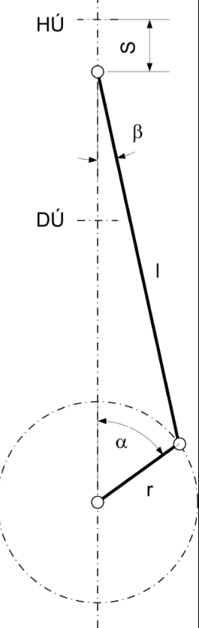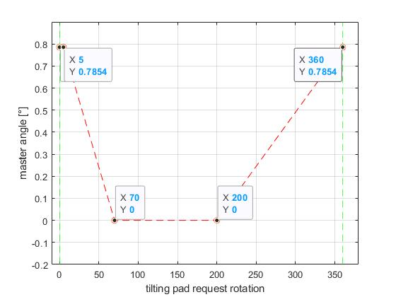

It is clear that the cyclical motion of the tilting pad is bounded between a maximum span of 45° (0.7854 radians) thus the most suitable way to obtain such a motion is a slider crank mechanism in winch the rotation of the pad is driven by the crank.

Such a mechanism is composed by a hinged rotating link (the crank) and a slider link connected with the first one. For our porpoise, the driver function is done by the slider and the follower is the crank.

The slider crank needs to be drawn so that comply with the precision point. In order to do that, the closure equations of the mechanism are carry out:

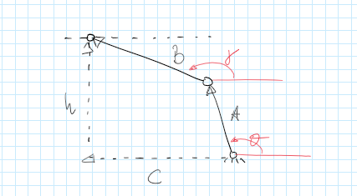

$$\left\{\begin{aligned}A+B=C+h \\ h=1\end{aligned}\right.$$

Where $A$, $B$ and $C$ are the vectoral representations of the link in the complex plane and h is a fixed length that is the distance between the sliding axis of $B$ and the ground revolute joint of $A$**.**

One can notice that the total variable are 6 (the length of each link, four, and the thee angles of $A$, $B$), that should be reduced to 5 if is considered h equals to one or better, normalized with respect to h. Than since there is not the absolute angle for any configurations, but only the difference in between two extreme configuration one equation may be added considering the angles of the second one as relative with respect to the first one so that one can impose this relative span of 45° and get at the end 6 unknowns in four trigonometric equations. To solve them at least 2 other variables must be arbitrary chosen. Just for example, the system below is solved by imposing gamma in the two configurations:

$$\left[\begin{matrix}Cθ_{1} & Cγ_{1} & 1 & 0 \\ Sθ_{1} & Sγ_{1} & 0 & 0 \\ Cθ_{2} & Cγ_{2} & 0 & 1 \\ Sθ_{2} & {Sγ}_{2} & 0 & 0\end{matrix}\right] \left(\begin{matrix}A \\ B \\ C_{1} \\ C_{2}\end{matrix}\right)= \left[\begin{matrix}0 \\ 1 \\ 0 \\ 1\end{matrix}\right]$$

Where $θ_{2}- θ_{1}=45°$ and $γ_{1,2}$ are chosen freely.

## Effects of $γ$ on transmission angles

The transmission angle is related to the active component of the force transmitted by the slider to the crank so that at a value of 90° correspond a complete transmission of the force.

The same concept could be watched from the opposite: since the task of the subsystem does not involve considerable external forces, the only significant are inertia (and also friction has to be considered somehow) so that a ‘good’ transmission angle means that the force required to drive all the forces from the tilting pad side are reduced to the minimum (geometrically speaking).

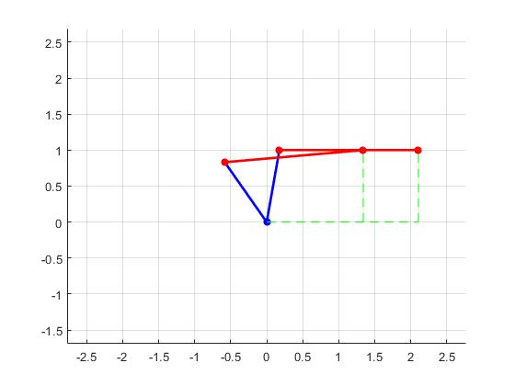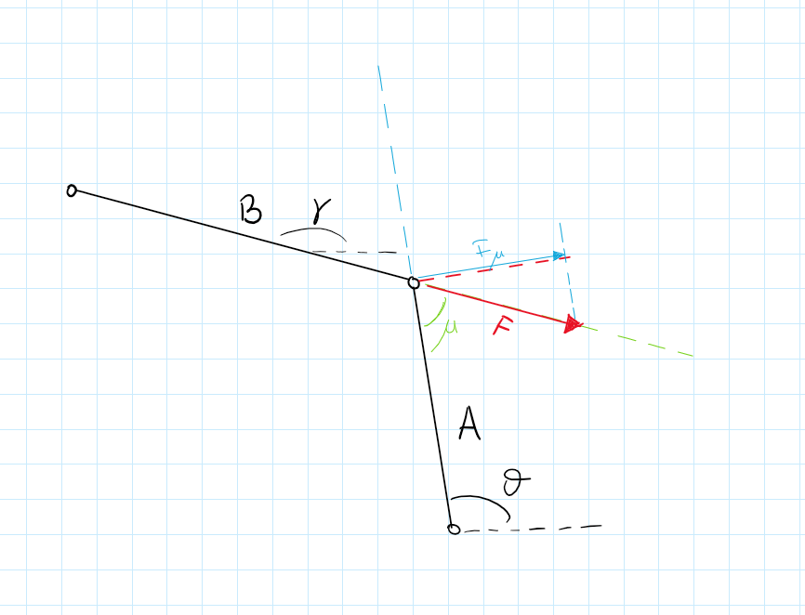

Values of gamma near to 90° shifted with respect to theta are suitable for our porpoise. The table below shows our project choices in the two extreme configurations.

|  |  |  |
| --- | --- | --- |
| Config. | Gamma (°) | Theta (°) |
| 1 | 0 | 80 |
| 2 | 5 | 145 |

|  |  |  |  |
| --- | --- | --- | --- |
| Config. | A | B | C |
| 1 | 1.0154 | 1.9300 | 2.1063 |
| 2 | 1.0154 | 1.9300 | 1.3402 |

Notice that the values of the length are all normalized with respect to h.

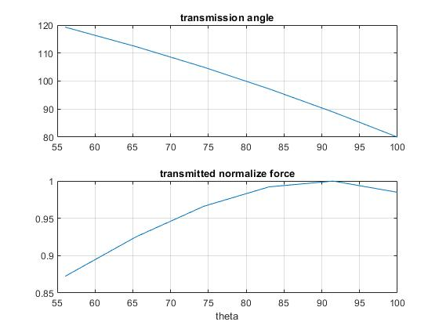

*1* value of the transmission angle with respect to theta and percentage of the force that is transmitted.